EVOLUTION OF MILK PRODUCTION IN THE NORTH EASTERN REGION OF ROMANIA TNR 14, BOLD, CAPITALS, CENTERED

Firstname FAMILY NAME¹, Firstname FAMILY NAME² TNR 12, Bold, Centered

¹University of Agronomic Sciences and Veterinary Medicine of Bucharest, 59 Marasti Blvd, District 1, Bucharest, Romania TNR 12, Centered
²Ministry of Agriculture and Rural Development, 24 Carol I Avenue, District 3, 020291, Bucharest, Romania TNR 12, Centered

Corresponding author email: author_email@gmail.com TNR 12, Centered

Abstract TNR 10, Bold, Italic, justified, no indentation

The paper aimed to present the evolution of Milk Production during the period 1990 -2011 in the North West Region of Romania, including Iasi, Botoşani and Suceava counties. It is based on the statistical data provided by Ministry of Agriculture, Forests and Rural Development. The data have been processed into the following indicators: cattle livestock, number of dairy cows, milk yield, and milk production. During the analyzed period, cattle livestock has continuously decreased, so that in the year 2011 there are just 1,440 thousand cows in Romania of which in the North Eastern part are raised about 25%. Milk yield has increased from 2,850 kg/cow in the year 1990 to 3,980 kg/cow/year in the year 2011, but total milk production has decreased taking into account the reduced number of cows. As a conclusion, the North East region is traditionally suitable for cow rearing, due to its pastures and meadows, the important number of cow stock and possibilities to produce ecological milk. TNR 10, Italic, justified, no indentation, minimum 100 and maximum 180 words (10 rows)

Key words: evolution, milk production, NW Region, Romania, trends. TNR 10, Italic, no indentation, maximum 5 words

introduction TNR 12 Bold

Milk is an important food both for humans and animals. Dairy farming is an important branch of agriculture in many countries and it has many problems mainly where small farms are the basic producing units (Millogo et al., 2008; Adams & Ishler, 2009). TNR 12, no indentation (the row starts right from the left margin), alignment justified
After 1989, the number of cattle stocks has seriously decreased due to the dissolution of the state enterprises and cooperatives and numerous slaughtered animals (Gavrilescu, 2000; Oancea, 2003).
At present the number of dairy cows counts for about 2,600 million heads and are mainly raised in private subsistence households (Grodea, 2009).
Milk production is on the second position in Romania’s agriculture after meat, in 2007 representing 21% of animal production value (Zahiu et al., 2010).
In this context, the paper presents an analysis of the evolution of milk production in the North East region of Romania, in order to put into evidence the evolution of the number of dairy cows, milk yield and total milk production in the period 1990-2010.

MATERIALS AND METHODS TNR 12

In order to characterize the evolution of milk production, the following indicators were used: number of cattle stocks, of which dairy cows and heifers, milk yield and milk production, milk consumption per inhabitant, number of dairy farms and cow density per ha.
The period analysed in this study was 1990-2010.
The data, collected from Ministry of Agriculture and Rural Development, have been statistically processed and interpreted, building the trend line and setting up the forecast based on simulation models for the period 2012-2015.

RESULTS AND DISCUSSIONS TNR 12

The cattle livestock has continuously decreased from 5,381 thousand heads in the year 1990 to 2,680 thousand heads in the year 2010, as a result of the dissolution of the agricultural units and of the fact that many old cattle have been slaughtered because of their low production (Zahiu et al., 2010).
The number of dairy cows has deeply decreased in the analyzed period from 3,200 thousand heads in the year 1990 to 1,440 thousand heads in the year 2010. The majority of dairy cows were raised in small subsistence farms where the possibilities to assure a better cow maintenance and manly feeding are reduced (Gavrilescu, 2000).
Therefore, in 2010, in Romania there were just 45% of dairy cows compared to the year 1990. Taking into account the dynamics of cattle and dairy cows stock, the share of dairy cows in the cattle stock has recorded a similar decreasing trend. In the year 1990, dairy cows represented 59.46% of the cattle livestock and in the year 2010, they registered just 53.73% (Table 1).

Table 1. Evolution of Dairy Cows during the period 1990-2010 (thousand heads) TNR 10, alignment centered and 6 pt spacing paragraph after
Specification  TNR 10 or smaller | 1990 | 1995 | 2000 | 2005 | 2010 | 2010/  1990  (%)
Cattle | 5,381 | 4,100 | 3,520 | 3,050 | 2,680 | 49.80
Dairy cows | 3,200 | 2,200 | 1,830 | 1,600 | 1,440 | 45.00
Share of dairy cows in total cattle stock (%) | 59.46 | 53.65 | 51.98 | 52.45 | 53.73 | -

A similar evolution of cattle and dairy cow stock has been noticed in the North Eastern part of Romania in Iasi, Suceava and Botosani counties (Figure 1).

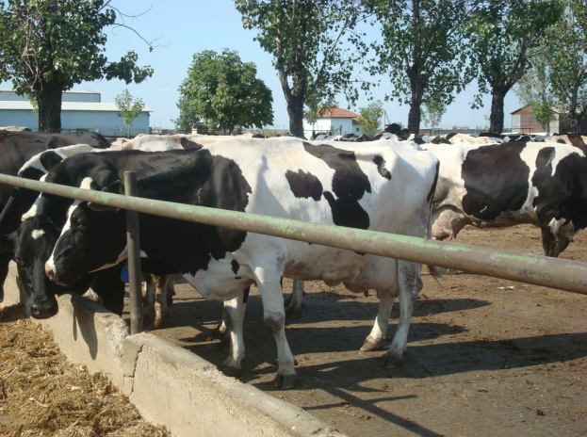
Figure 1. View from a Dairy Farm in the NE part of Romania

The average milk yield has registered a continuously increase from 2,063 kg/cow in the year 1990 to 3,980 kg /cow in the year 2010. This positive aspect was determined by the reduced number of cows which has allowed a better feeding. Farmers have also selected the best cows based on their own performance and culled the ones registering a lower yield.
As a result, in 2010, the average milk yield was 1.92 times higher than in 1990.
In the North Eastern part of Romania, the average milk yield registered a similar trend increasing from 1,980 kg/cow/lactation in the year 1990 to 3,875 kg/cow/lactation in the year 2010 (Figure 2).
Milk Production has been 66,016 thousand hl in the year 1990, but in the coming 5 years it has deeply decreased due to the lower number of dairy cows.

Figure 2. Evolution of Average Milk Yield

In the year 1995, milk production was 48,400 thousand hl, by 26.69% less than in 1990.
Starting from the year 1995, milk production has recorded a continuous increase, so that in 2010 it reached 57,312 thousand hl, being by 13.19% less than in the year 1990 (Table 2).

Table 2. Evolution of Milk Production (kg/year)
Specification | 1990 | 1995 | 2000 | 2005 | 2010 | 2010/  1990  (%)
Milk Production | 66,016 | 48,400 | 49,044 | 51,840 | 57,312 | 86.81

In the North Eastern part of Romania, dairy farmers give an important contribution to milk production in the country because of the high number of cows grown in this area, their production potential and pastures and meadows availability.
However, milk collection and marketing are the major problems farmers were facing with during the last 15 years. Milk market is unbalanced due to the inappropriate milk offer/demand ratio.
The low milk offer has obliged Romania to import milk for assuring raw material for milk processing industry.
Milk processors are complaining of milk quality because the small subsistence farms have no milking machines and milk tanks and do not respect milk hygiene rules (Table 3). About 92% of dairy farms are represented by small farms raising 1-2 cows. The dispersion of the farms in the territory creates difficulties to milk processors in collecting milk increasing milk transportation cost.
Romania’s entry into the EU has imposed the common market milk quality standards. In this context, the concentration of reduced sugars after hydrolysis with enzymatic mixtures has become a relevant analytical parameter (Figure 3). Measuring these sugars provides insights into the carbohydrate content and enzymatic breakdown efficiency, contributing to the evaluation of milk quality, processing potential, and compliance with EU regulations.

Table 3. Mycotoxin concentrations in experimental diets (mg/kg)
Mycotoxin¹ | Control | Contaminated grains | Contaminated grains + GMA²
Hens
DON 0.2 12.6 13.8 | 0.2 | 12.6 | 13.2
15-acetyl-DON ND3 1.0 1.2 | ND | 1 | 01.5
ZearalenoneND 0.6 0.5 | ND | 0.6 | 0.7
Roosters
DON 0.9 6.4 9.2 | 0.9 | 6.4 | 8.2
15-acetyl-DON ND 0.5 0.7 | ND | 0.5 | 0.7
ZearalenoneND 0.3 0.4 | ND | 0.3 | 0.6
¹Other mycotoxins, including T-2 toxin, zearalenol, aflatoxin, were also measured, but they were below the limits of detection. DON = deoxynivalenol.
²GMA = polymeric glucomannanmycotoxin adsorbent.
³ND = not detectable.

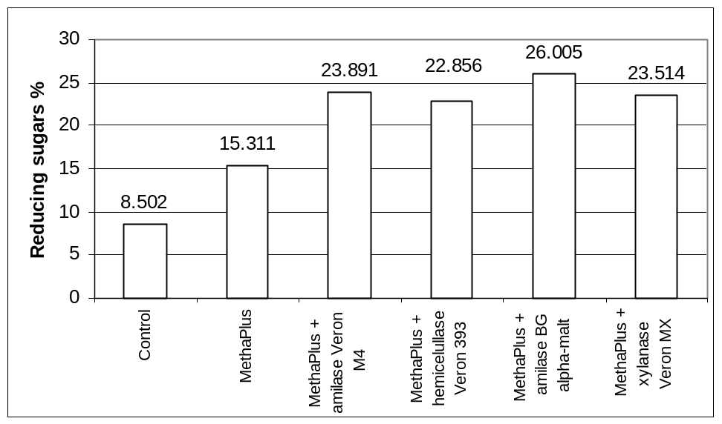
Figure 3. Concentration of reduced sugars after hydrolysis with enzymatic mixtures TNR 10, alignment centered and 6 pt spacing paragraph before

Milk price is deeply influenced by offer/demand ration and also by milk quality. At present, milk quality is determined not only by fat percentage but also by number of somatic cells and number of pathogen germs.
Even thou milk price has continuously increased, farmers are complaining that it is still very low as long as farm input price have also increased.
Due to the rules imposed by the EU, the direct delivery of milk to peasant market has been diminished. It is estimated that at resent only about 30-40% of milk offer achieved in the peasant subsistence households complies with the EU standards.
More than that, despite that milk yield has increased it is still very low in comparison with the performance carried out in other EU countries. For instance, in France, Hungary and Poland milk yield is by 20-30% higher than in our country.
However, Romania produces about 3-4% of the EU milk production contributing annually by about 5,400-5,800 thousand tones.

CONCLUSIONS TNR 12

The number of dairy cows has continuously decreased during the period 1990-2010, with a negative impact upon milk production.
Milk yield is the only positive aspect, because it has increased reaching 3,980 kg per cow in the year 2010.
Also, the assessment of reduced sugar concentrations after enzymatic hydrolysis provides a valuable tool for evaluating milk quality and processing efficiency, supporting Romania’s alignment with EU standards and enhancing the competitiveness of its dairy sector.
As a consequence of the reduced number of cows but an increased milk yield, milk production has continuously increased, except the year 1995 when it recorded the lowest level.
The North Eastern region is traditionally suitable for cow rearing, due to its pastures and meadows, the important number of cow livestock and possibilities to produce ecological milk.
ACKNOWLEDGEMENTS TNR 12

This research work was carried out with the support of Ministry of Agriculture and Rural Development, Department of Statistics and also was financed from Project PN II Partnership No.
2365/2007.

USE OF GENERATIVE ARTIFICIAL INTELLIGENCE (GenAI) TNR 12

The authors declare the use of Generative Artificial Intelligence (GenAI) tools in the preparation of this manuscript. GenAI was used exclusively for language editing and text refinement in the Introduction and Conclusions sections. All scientific content, data analysis, and interpretations were developed and verified by the authors.

REFERENCES TNR 12

Adams, R. S., & Ishler, V. A. (2009). Trouble-shooting problems with low milk production. Dairy and Animal Science, 4(1), 98–116. TNR 10, indentation hanging 0.5 cm, alignment justified. The references must be written in alphabetical order by authors’ names, in APA style (https://courses.lumenlearning.com/boundless-writing/chapter/apa-citations-and-references/).
Gavrilescu, D. (2000). Dairy farming in small subsistence households. Tribuna Economica, 1(5), 5–7.
Grodea, M. (2009). Milk chain in Romania-post adhesion effects. Scientific Papers Agricultural Management, XI (2), 53–57.
Millogo, V., Ouedraogo, G. A., Agenas, S., & Svennersten-Sjaunja, K. (2008). Survey on dairy cattle milk production and milk quality problems in peri-urban areas in Burkina Faso. African Journal of Agricultural Research, 3(3), 215–224.
Oancea, M. (2003). Modern management of agricultural holdings. Bucharest, RO: Ceres Publishing House.
Zahiu, L., Tom, E., Dachi, A., & Alexandr, C. (2010). Agriculture in Romania’s economy-between expectations and realities. Bucharest, RO: Ceres Publishing House.

